IOT Based Pipe Burst Detection In Water Distribution Systems

Suri Shanmukh,Meka Poorna sai,S.Sai Sri Charan
Students, Department of Electronics and Communication Engineering, SASTRA Deemed University
Thanjavur, Tamil Nadu
surishanmukh@gmail.com, mpoornasai@gmail.com, charanmsd72@gmail.com

Nithya Chidambaram
Faculty, Department of Electronics and Communication Engineering, SASTRA Deemed University
Thanjavur, Tamil Nadu
cnithya@ece.sastra.edu

Abstract—Agriculture is the heart of our vibrant culture which is the backbone of our country’s economy. India’s population is 1.2billion now which means that the non-renewable resources must be used judiciously. Today the most of the places in India suffer from drought due to lack of abundant rainfall. Manual supervision is always needed for the traditional farming. Hence it’s the duty of every engineer of the country to contribute for its technological development. This thought was the foundation for our project and the objective of this paper, is to automate the irrigation system. The proposed methodology includes node microcontroller unit (Node mcu) to monitor the water flow and controlling the water supply and communication is done using IOT. The idea of Internet of Things (IOT) has been integrated with automation to design the proposed “PIPE BURST DETECTION IN WATER DISTRIBUTION SYSTEMS”.

Keywords— Node mcu; IOT; Water flow Sensor; Sensor based Irrigation.

Introduction
Agriculture is one of the most important factor which contributes to the growth of the economy of country where it uses about 70% of the fresh water, mainly from the underground reserves [1]. But water is one of the most increasing scarce resource, so effective irrigation water management with well timing and regulating system must be implemented to satisfy the need of the crop without wasting water, soil and crop nutrients should be done [2], [3].One of the method is by measuring the flow of fluid which is used to estimate the productivity of the field. It is also an effective way to keep an eye on the pumping system such as pipe leakage etc [4]. Flow rate can be measured with contact type or non-contact type of sensor. Such as ultrasonic sensor, Auxiliary fluid flow meter, Hall Effect sensor [5].
Nevertheless the life expectancy and maintenance specifications of the flow meters are affected by some constraints. The major task is to choose the specific instrument to that precise application. Although there are many flow meters that can measure the flow rates, they don’t have a provision to control the flow rate. Hence this needs to be supervised by a worker to control the water pumping through the motor which leads to the wastage of manpower [6], [7]. So Applying necessary amount of water at the right time is the main motto of the Automated Farming, regardless of the presence of worker to power on and off the motor [8]. This is achieved by creating an appliance which will continuously monitor the water flow rate and accordingly furnishing the water to the field [9].

With the advantage of using the Node mcu boards, being open source will reduce the complexity for the programmer. Using GUI.YF-S201 flow sensor sensing of the liquid flow rate of pipe is done, which in turn controls the total system using Node mcu microcontroller and IOT. This will help the farmers to continuously monitor the water flow, thereby making their work easy and the productivity of the crop will be more.

PROPOSED METHOD
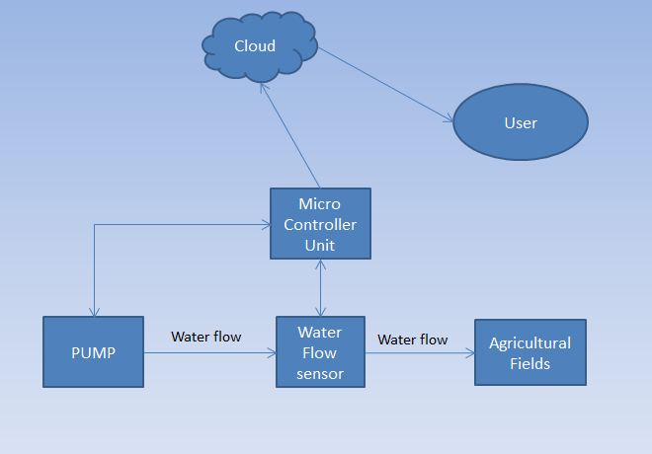
- General block diagram

Terms
Node mcu- microcontroller
f:- frequency
fr: Flow rate.
A flow sensor is placed in line with the water line which is connected to a water pump. The status of the pump can be varied using a microcontroller. The water will be flowing through the sensor, sends signal to microcontroller, and the water flow readings will be read for every second. The readings taken will be continuously uploaded into a cloud through the microcontroller which has an inbuilt WiFi module embedded in it and helps in connecting the cloud. The readings will be continuously compared with the threshold and sends a signal to the microcontroller to turn off the pump. On turning off the pump through microcontroller, the cloud sends a message to user.

Algorithm
Step1: Start the process.
Step2: Initialize the power supply to the microcontroller and pump.
Step3: Calculate the flow rate(fr)=frequency(f)*4.5 liters/min
Step4: Check the flow rate (greater than or less than)
Step5: If the flow rate is less than a fixed criteria, turn off the pump
Step6: Configure the message to be sent by the cloud.
Step7: After giving the reset command the microcontroller comes to the original state.
Step8: Restart the process (if required) or stop the process.
The flow sensor placement will be a key issue in this method. The flow sensor is expected to be placed at the end of the pipeline, where the water will be flowing to the fields. We can further use an array of sensors to detect the burst for a multiple pipeline system. The burst can be detected only for the pipeline being an input to the sensor. This method deals with single pipelined system as a prototype for other pipeline system.

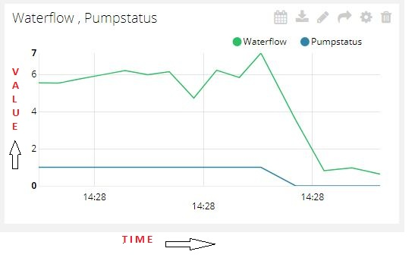
- Graphical representation of uploaded values of flowrate and status of pump.
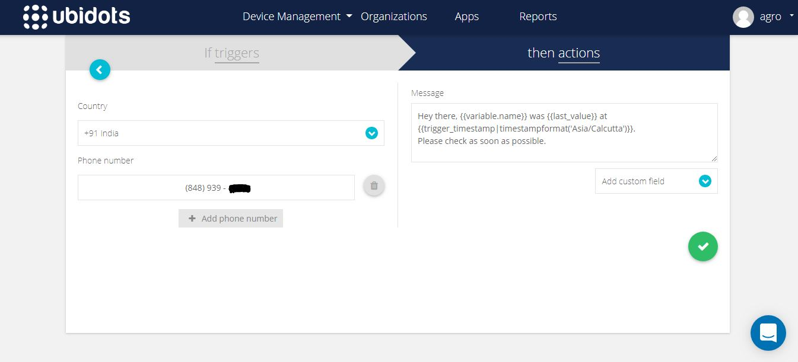
- Configuration of message to be sent by the cloud


- Message sent to the user.

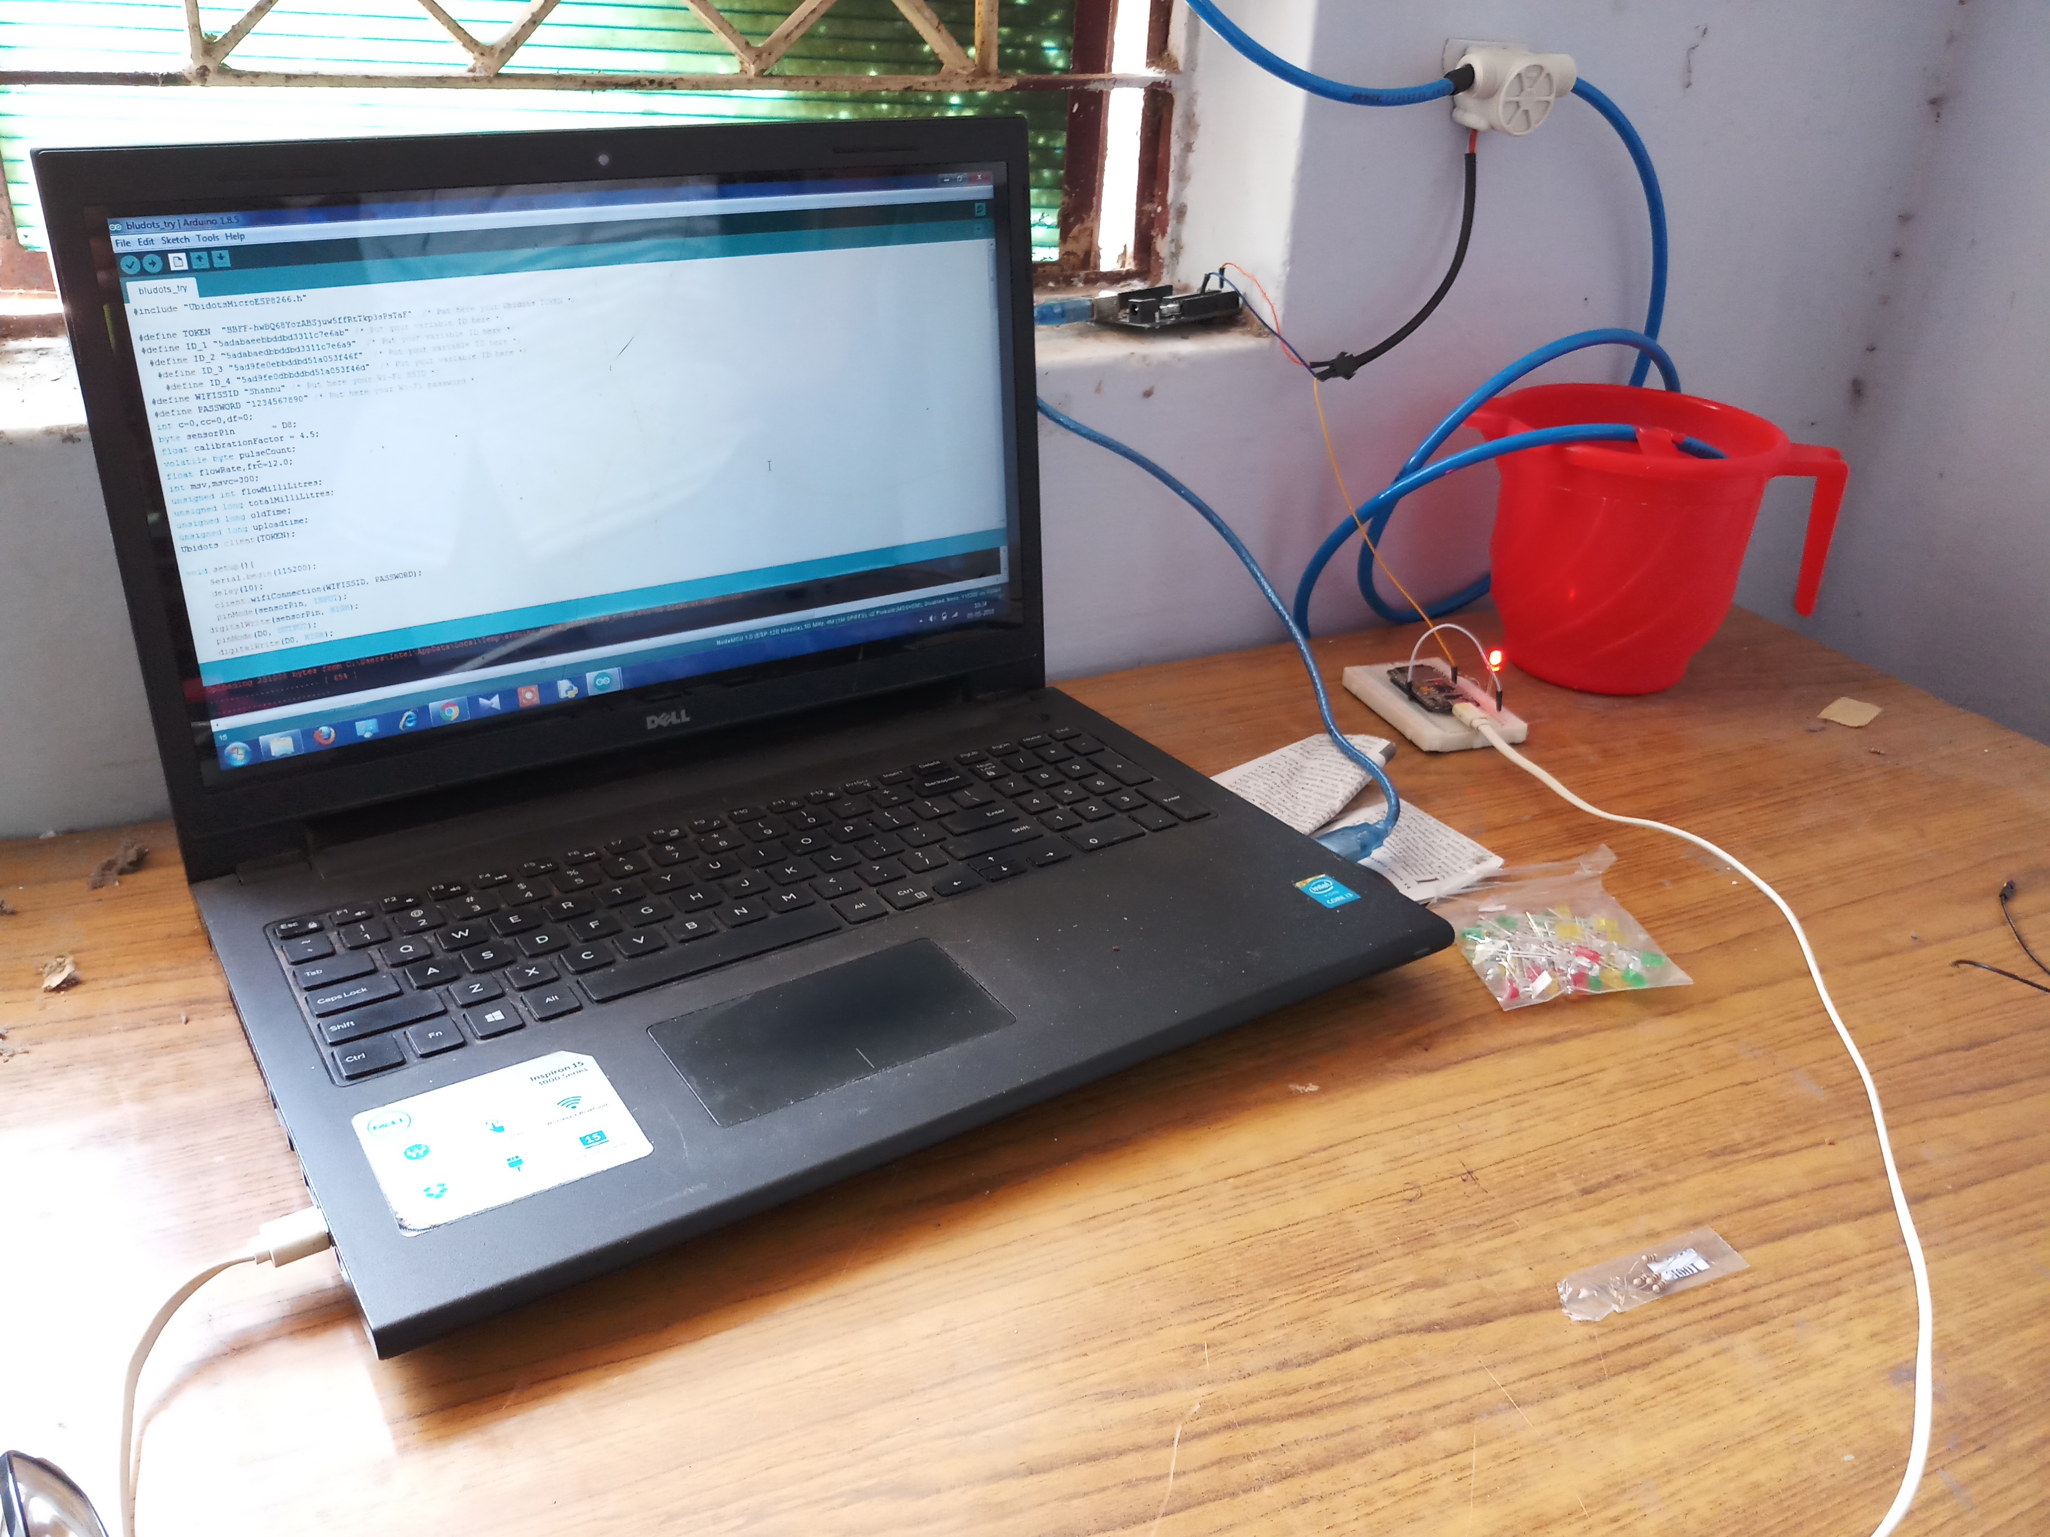
- Experimental setup
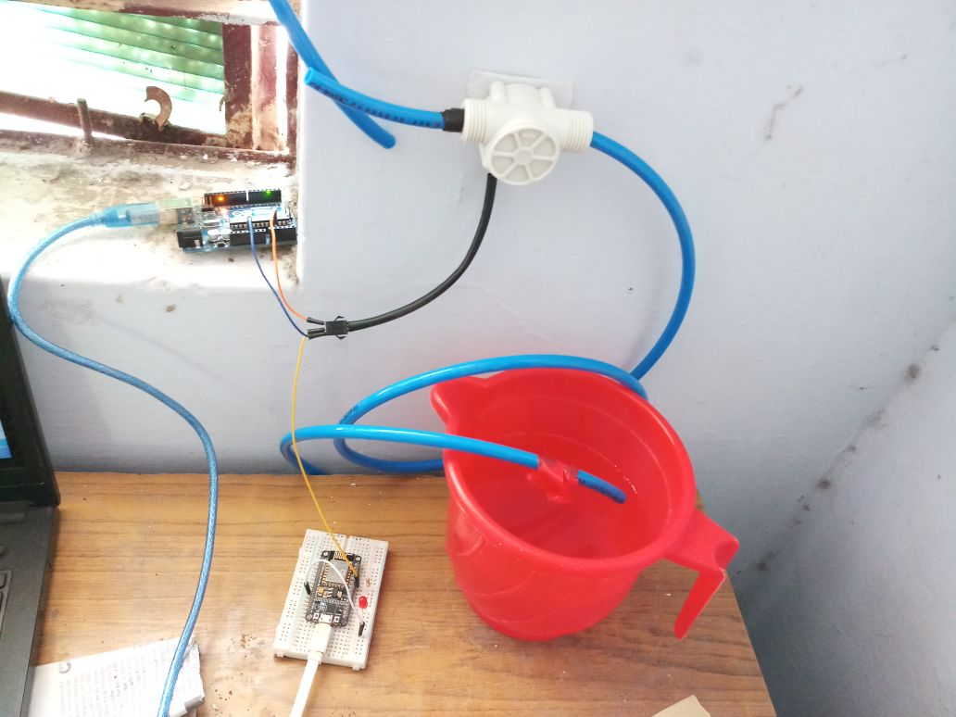
- System condition when burst occours

RESULTS AND DISCUSSION
The obtained values from the sensor enable the system to turn the LED on and off which represents the status of the pump. The experimental setup is shown in figure 5 where the water flows through the water flow sensor and gives the value to the Node mcu. Here Arduino is used as a power source to the Flow sensor. The water flows through the pipe and gets collected in a tumbler (representing an agricultural field). The water flow is manipulated manually by a tap.
The values are graphically represented in figure 2 and it depicts that the values of flow rate and the status of the LED is being uploaded into the cloud where value 1 of the pump status represents the LED is on and value 0 represents that the LED is off. When there is a drastic decrease in the flow rate the LED is turned off by the microcontroller and this can be seen in figure 6 where the led represents the status of the motor. In the real time scenario when a pipe bursts or breaks, there will be a change in flow-rate which can be detected and make the pump to turn off thereby conserving water.
On detection of drastic decrease in flow-rate then a message will be sent to the cultivator. Figure 3 represents configuration of message that has to be sent to the user. This will contain the value of pump status and the timestamp when the pump was turned off. Additional information can also be sent depending on the type of message that has to be sent. Figure 4 represents the message that has been sent from the cloud to mobile so that we can alert the user about the situation. This will decrease the intervention of farmers and helps in conservation of water.

CONCLUSION
The proposed methodology is highly practical and useful in remote farming areas where automation plays a vital role in saving water and proves to be useful in places with water scarcity. Most importantly this ensures soil and fertilisers do not get washed away due to overwatering. Furthermore, this can also be used for the shipment of crude oil under-water where the oil spill can cause a catastrophic damage to the marine life. The intervention of the farmer has extremely reduced and keeps him notified in case there is a fault in the pumping system. The proposed idea in provides a reliable and error-detection system for automated farming which could help to conserve water and at the same time reduce the power consumption.

References

[1] K. Bourzac, “Water: The flow of technology,” Nature, vol. 501, no. 7468, pp. S4–S6, 2013.
[2] R. R. Iyengar, “The water flow monitoring module,” Int. J. Eng. Res. Gen. Sci., vol. 4, no. 3, pp. 106–113, 2016.
[3] R. Sood, M. Kaur, and H. Lenka, “Design and Development of Automatic Water Flow Meter,” Int. J. Comput. Sci. Eng. Appl., vol. 3, no. 3, pp. 49–59, 2013.
[4] M. L. Ali, R. Ridoy, U. Barua, and M. B. Alamgir, “Design and Fabrication of a turbine Flow meter,” 11th Glob. Eng. Sci. Technol. Conf., vol. 4, no. 1, pp. 1–11, 2015.
[5] J. R. Gatabi, F. Forouzbakhsh, H. E. Darkhaneh, Z. R. Gatabi, M. Janipour, and I. R. Gatabi, “Auxiliary fluid flowmeter,” Eur. J. Sci. Res., vol. 42, no. 1, 2010.
[6] . N. S., “Raspberry Pi Based Liquid Flow Monitoring and Control,” Int. J. Res. Eng. Technol., vol. 03, no. 07, pp. 122–125, 2014.
[7] J. S. S.Uma, “Human Interaction Pattern Mining Using Enhanced Artificial Bee Colony Algorithm S.,” Int. J. Innov. Res. Comput. Commun. Eng., vol. 3, no. 10, pp. 10131–10138, 2015.
[8] K. Kansara, V. Zaveri, S. Shah, S. Delwadkar, and K. Jani, “Sensor based Automated Irrigation System with IOT : A Technical Review Sensor based Automated Irrigation System with IOT : A Technical Review,” Int. J. Comput. Sci. Inf. Technol., vol. 6, no. 6, pp. 5331–5333, 2015.
[9]A. S. -Harshita Chugh, Dushyant singh, Shahensha shaik, “IOT based Smart Irrigation System,” Int. Res. J. Eng. Technol., vol. 4, no. 9, pp. 7–11, 2017.

